Financial Rules of Arts for Life

General arrangements

  - The group as a whole acts as the management committee; we have no elected committee.
- The management committee is responsible for ensuring that the group is well managed and that we look after our income properly and put it to best use.
- We will keep appropriate financial records, including:
  - an account book or spreadsheet recording all the transactions in the bank account(s)
  - bank statements or building society passbook
  - a petty cash book (if we make cash payments)
  - details of all funds received
  - invoices and other receipts for all payments
  - PAYE records (if we employ paid workers).
- Our financial year ends on 27/03/2024
We will draw up accounts at the end of the financial year and have them examined by a suitable person who is independent of the group. The annual accounts will be presented to the Annual General Meeting for approval.
Before the start of the financial year, we will set a budget for the following year.
- We will discuss a financial report at each committee meeting showing money received, payments, and remaining funds. It will also show expected future receipts and payments.
Bank accounts
- We have an account with Wave community bank, Hove town hall, Tisbury road, Hove, BN3 3BQ
- All bank transactions will go through our current account. To withdraw money from any other account, we shall first transfer it to the current account and withdraw it from there. If we pay money into any other account, it will be as a transfer from the current account.
- At least two members of the management committee will be signatories to the accounts.
- Any withdrawals or transfers between accounts will be signed by the two signatories. We expect that one of these will be the treasurer. If not, we will give the treasurer full details of the payment.
- We will ask the bank to provide statements every month and will check the statements against our records.

Income
- When we receive cash at exhibitions or events, two members of the group will count up the cash, make a note of the total and sign for it.
- When the treasurer collects cash from a group member, the treasurer will issue a receipt.
- Details of cash received will be entered in the cashbook.

  - We shall bank all cash received – we will not use it for cash payments. We expect that cash over £100 will be banked within a week.
  - We will use small amounts of cash received as petty cash.
- We will record details of cheques received in the account book and bank the cheques within one month.
- We will record details of all bank transfer (BACs) payments in the account book.
- The treasurer will keep files of paperwork relating to cheques and BACs payments (e.g. grant award letters or copies of receipts issued by the group).

Buying goods and services
- Our management committee will agree payments in advance. This will either be shown in our annual budget or discussed at a meeting during the year.
- The treasurer will keep a file of all the paperwork and check invoices before making payments.

Payments by cheque, direct debit, bank transfer or debit card
- We will not sign a cheque, or authorise a direct debit, bank transfer (BACs) or debit card payments without paperwork to support the payment.
- Two signatories are required on each cheque. Cheque stubs will be completed at the time of payment.
- All other payments (including BACS, debit card payments, standing orders and direct debits) must be signed for in advance by two signatories on our own payment form. The payment form will include the following details: payee; date; amount; type of payment (e.g. BACS, standing order); and space for two signatures.
- We will never sign a blank cheque.
- We will record details of payment on the accounts book/spreadsheet:
  - cheque number / type of payment
  - date
  - who signed the cheque / payment form

Petty cash
- We will keep a small float of £50 for small payments such as bus fares and tea & coffee. We will keep the float separate from incoming cash and withdraw cash from the bank to make up the float. Cash withdrawals from the bank account will require 2 signatories. We will enter in the petty cash book the amount of cash drawn from the bank and details of payments.
- No payments above £50 will be made by cash.
- We will record payments on a petty cash slip and keep till receipts, bus tickets, etc.

Staff wages
- We will keep records of staff wages in accordance with PAYE and National Insurance regulations.
- Where casual or part-time staff are paid in cash, the treasurer will make sure that staff sign a wages record sheet.
This policy was agreed at the Inaugural General Meeting of Arts for life

Date 23/10/2023

Name and position in group …EMMA OTTLEY CHAIR

Signed 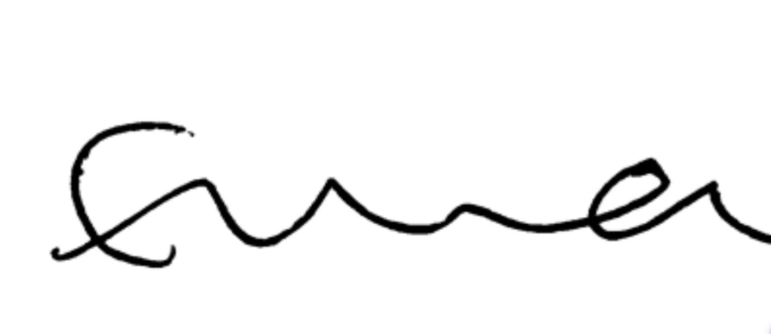

Name and position in group …LAYLA JADE REDWAY MAGUIRE SECRETARY

Signed 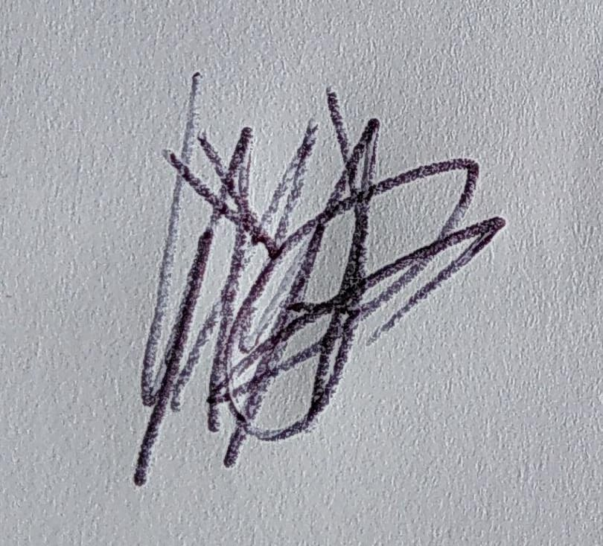

Name and position in group …HEATHER MCKNIGHT TREASURER

Signed