Arts for life Equality and Diversity Policy
Aims
Arts for life is open to all people who share the group's aims. We aim to help the members to have an atmosphere of friendship, respect and care for each other. In particular, we aim to treat every member equally, regardless of their age, disability, gender reassignment, marriage or civil partnership, pregnancy or maternity, race, religion or belief, sex, or sexual orientation

Accessibility
All our meetings and events are held in venues that are accessible to wheelchair users. When there are more than 40 people at an event we aim to use a PA system.

We are committed to ensuring any member of Arts for life able to attend our activities, so we will reassess our access requirements to meet the needs of new members.

Diversity
Our Association belongs to all members. We aim to organise a range of events and activities to suit the interests and meet the needs of a wide variety of people.

The group should be open to new ideas, and particularly prioritise opportunities for residents to express themselves and with one another through arts projects.

Inclusion and respect
Every member of Arts for life should be made to feel equally welcome and included at all Arts for life meetings and events.

Sexist, racist, homophobic, transphobic or otherwise offensive and inflammatory remarks and behaviour are not acceptable. These constitute harassment, and have no place in the group.

Dealing with discrimination and harassment
If any tenant feels they have been discriminated against by the group or harassed at a group event they should raise this with the committee.

The committee will investigate the complaint, listening to all members involved. (If the complaint is against a committee member, that member will not be part of conducting the investigation).

If the complaint is against a particular individual, this person will have the opportunity to express their point of view, accompanied by a friend. The person making the complaint will also have this opportunity.

If the complaint is against the group as a whole, the Committee must work to ensure that such discrimination is not repeated in the future, and must inform the members of how they propose to do this.

Any decision to exclude a person from the organisation due to discriminatory or harassing behaviour will be made with reference to the group’s constitution. The group will support people who feel they have been harassed or discriminated against, and will not victimise or treat them less well because they have raised this.

This policy was agreed at the Inaugural General Meeting of Arts for life

Date 23/10/2023

Name and position in group …EMMA OTTLEY CHAIR

Signed 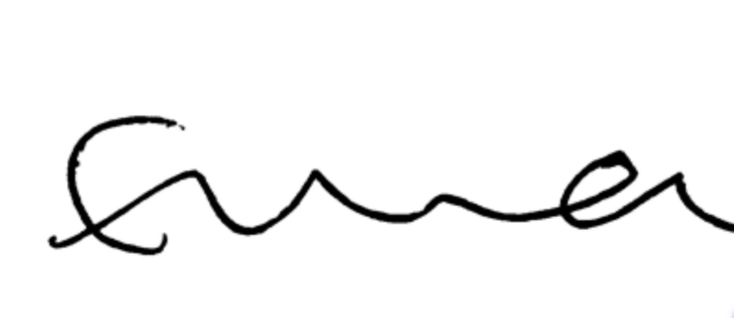

Name and position in group …LAYLA JADE REDWAY MAGUIRE SECRETARY

Signed 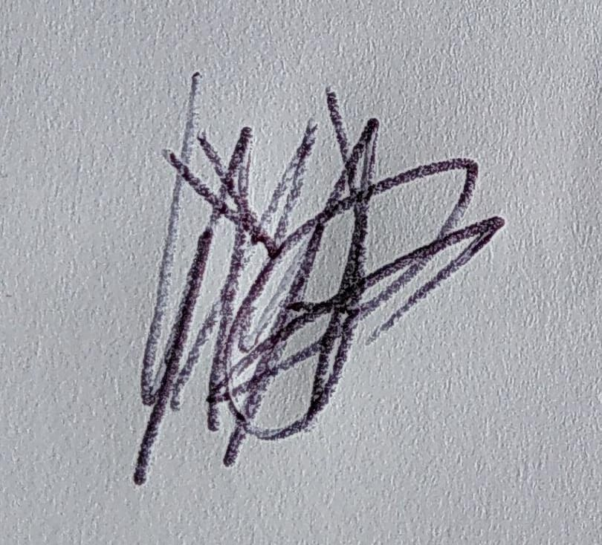

Name and position in group …HEATHER MCKNIGHT TREASURER

Signed 