Environmental policy statement

Arts for life recognises we are in a time of climate emergency and that we must take a responsibility to act on this within the scope of our collective and in line with our constitution. Our environmental statement is drawn from the Culture Takes Action framework created by Climate Museum UK. 1 We have selected the action points we are most capable as a collective of addressing through our work, and use this statement to inspire our day-to-day working, project planning and funding bids.

Truth-telling through Arts and Education
• Use participatory forms of engagement, to create space for dialogue and acknowledging shared truths can be agreed from different experiences.
• Nurture forgiveness, enabling truth-telling and dialogue between people with different experiences.
• Using arts & technology to make the environmental crisis more visible

Decarbonising cultural practice
• We will not apply for sponsorship by harmful industries
• We support eco-enterprise within cultural practice using wherever possible green materials, encouraging the re-use and sharing of materials and products through a ‘library of stuff’

Supporting transition by local communities
• Running projects that help imagine possible futures
• Provide cultural services as an alternative to consumerism
• Where possible promoting stewardship of biodiversity into our projects

Ambitious global system-changing action
• Create resources and space for activists to learn, and to plan for systemic change.
• Enable conversational learning to develop critical thinking and global.
• Practice or promote directly reparative forms of arts & design

Providing cultural therapy and care
• Innovate ways to tackle eco-anxiety in anticipation of trauma
• Help change attitudes to our fellow beings, to be more generous and less materialist.

Decolonising culture & seeking reparation
• Co-educate with and for those most affected by histories & impacts of climate crisis.
• Use cultural resources to learn and protect indigenous heritage, in collaboration.
• Recognise and tackle inequalities in cultural & environmental movements.

Ecological innovation & design
• Promote a ‘knowledge commons’: open up access to expertise, data and ideas.
• Encourage climate activism for all ages, and intergenerational sharing
• Prefigure and generate diverse ecological and social innovations such as micro solidarity, micro utopian approaches, where small projects can inspire bigger acts.
Adapting to impacts & protecting heritage
• Memorialise lost species, cultures & places; give space to spiritual activities and support grief at loss.
• Educate audiences, aiming for justice and care for migrants and climate refugees.
• Sign up to Culture Declares Emergency and engage with their resources.

This policy was agreed at the Inaugural General Meeting of Arts for life

Date 23/10/2023

Name and position in group …EMMA OTTLEY CHAIR

Signed 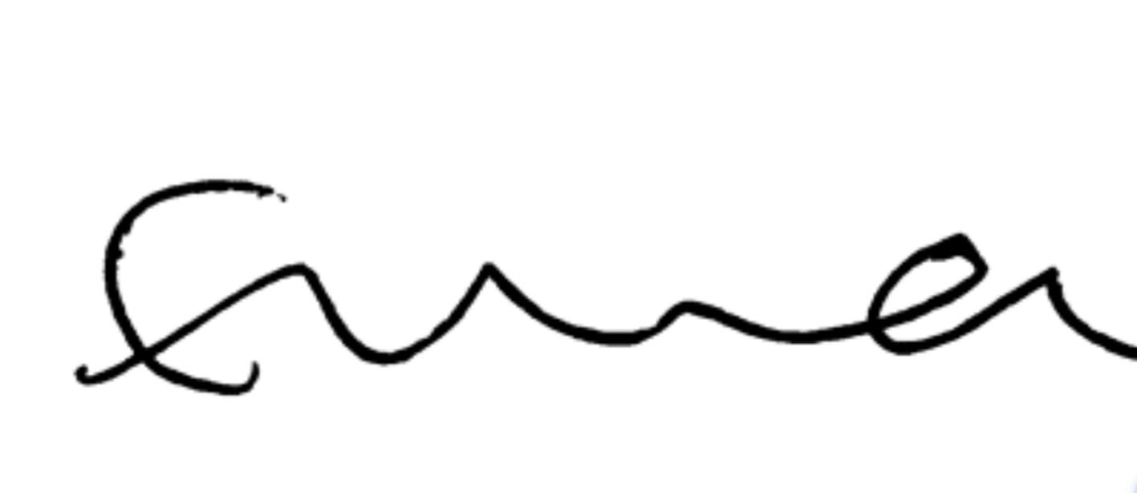

Name and position in group …LAYLA JADE REDWAY MAGUIRE SECRETARY

Signed 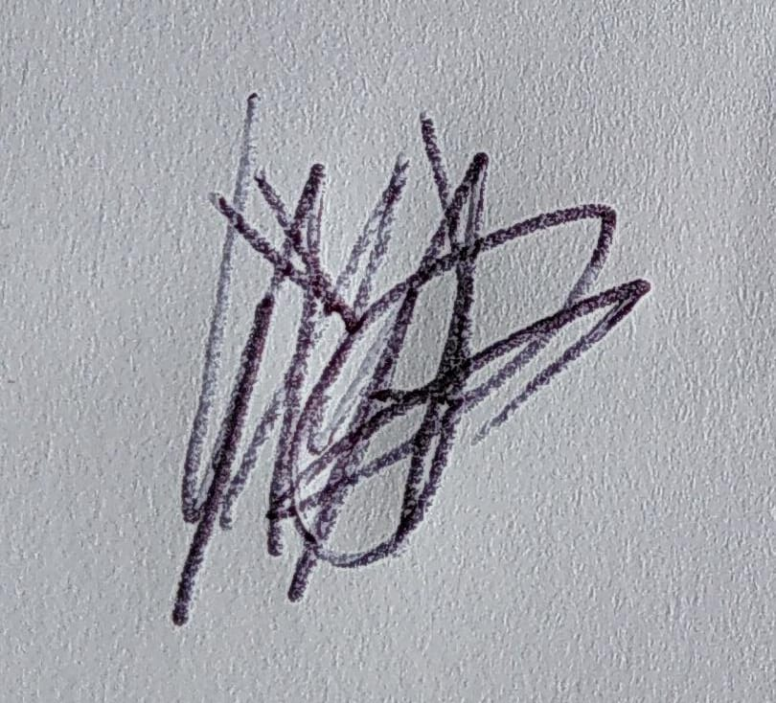

Name and position in group …HEATHER MCKNIGHT TREASURER

Signed