Arts for life Health and Safety Policy

As a project Arts for life has a legal responsibility to ensure that the project is compliant with Health and Safety law to ensure the safety of its beneficiaries, facilitators, consultants and trustees.

Statement of General Policy is:

- To provide adequate control of the health and safety risks arising from participant and volunteer opportunities.
- To consult with our participants / volunteers on matters affecting their health and safety
- To provide and maintain safe equipment.
- To provide information, instruction and supervision for beneficiaries
- To ensure all beneficiaries and staff are competent to do their tasks, and to give them adequate training
- To prevent accidents
- To maintain safe and healthy creative activity conditions
- To review and revise this policy as necessary at regular intervals

Responsibility for ensuring this policy is put into practice by Project Coordinator / Management Committee Health / Creative Practitioners and Mind Safety Officer:

- To communicate all relevant Health and Safety information to beneficiaries and management committee
- To ensure health and safety standards are maintained / improved
- To ensure Fire Safety is maintained and all beneficiaries are made aware of what to do in an event of a fire or an emergency
- To record and report Accidents & Incidents
- To coordinate training of beneficiaries and management committee so that they become safety representatives of the Arts for life project
- To fully administrate correct insurance: Professional indemnity and public liability as well as volunteer liability
- To train and be a qualified first aider.
- To administer first aid
- To complete risk assessments for each group activity
- To regularly monitor health and safety rules are followed

All volunteers/ Creative Practitioners have the legal duty to:

- Cooperate with facilitators on health and safety matters
- To take care and co-operate with facilitators and staff on points of Health and Safety
- Compliance with emergency arrangements that are communicated to all facilitators and staff
- Not to interfere with anything provided to safeguard their health and safety
- Carrying out tasks in a safe manner and following the Health and Safety rules
- Take reasonable care of their own health and safety
- To inform all health and safety concerns to an appropriate person
- Reporting any situations that may involve hazards
- To assist Project Coordinator in completion of risk assessments
- To assist Project Coordinator in logging of accidents or incidents
- To obey the drugs and alcohol policy of the organisation
- To not smoke within any building or enclosed space
- Beneficiaries / Creative Practitioners activity practice:
- Do not operate equipment unless you have been trained how to use it.
- Use work equipment in the safe way that you have been trained.
- Report any equipment problems to facilitator or staff as soon as possible
- Do not make repairs to any work equipment unless you have been trained to do so
- Wearing, storing and maintaining any personal protective equipment/clothing in the correct manner
- Hazardous substances must be used as instructed
- All hazardous substances that are not in use must be stored correctly
- Observe the instructions provided whilst handling glassware
- Use the correct tools provided at work
- Clear up any spillage within the work area
- Waste hazardous substances must be disposed of in the prescribed manner
- Do not allow hazardous substances to enter drains or sewers
- Make proper use of all equipment and facilities provided
- Keep all areas clean and tidy
- Dispose of all rubbish and waste materials using the facilities provided
- Report any hazardous conditions

Facilities

Arts for life will ensure that volunteer activities work space is maintained to an acceptable standard and that adequate welfare facilities are properly maintained, including ventilation, heating, lighting, décor, cleanliness and the provision of drinking water.

Arts for life will also ensuring that all volunteers receive adequate Health and Safety training to enable them to carry out volunteer opportunities, including suitable and sufficient training as part of the induction process

Arts for life will have:
- an up to date first aid kit
- Identify volunteers who are prepared to act as first aiders
- Cost and source appropriate training
- Ensure that first aiders have valid certificates of qualification
- All equipment used by volunteers and staff will be PATs Tested

Arts for life Health and Safety Consultation with beneficiaries

- To enable all beneficiaries to raise issue of concern relating to health and safety issues in the workplace consultation has to occur
- Arts for life will do this via consultation sessions with volunteers and with the management committee. Beneficiaries will be consulted on how they wish this to occur – e.g. through beneficiary representatives, through group meetings and the results of the consultation will be noted and published

Arts for life will also consult with beneficiaries on a one to one basis on matters of concern regarding Health and Safety

This policy was agreed at the Inaugural General Meeting of Arts for life
Date 23/10/2023

Name and position in group …EMMA OTTLEY CHAIR

Signed 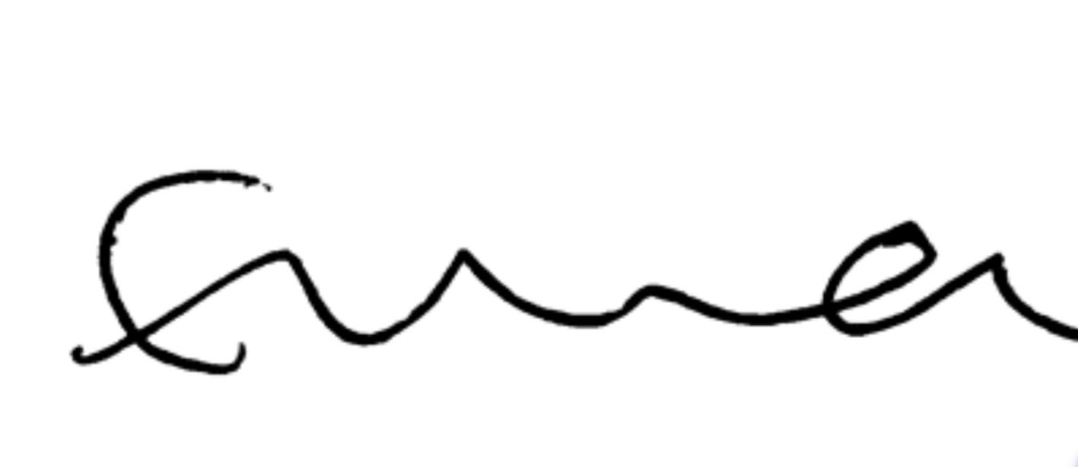

Name and position in group …LAYLA JADE REDWAY MAGUIRE SECRETARY

Signed 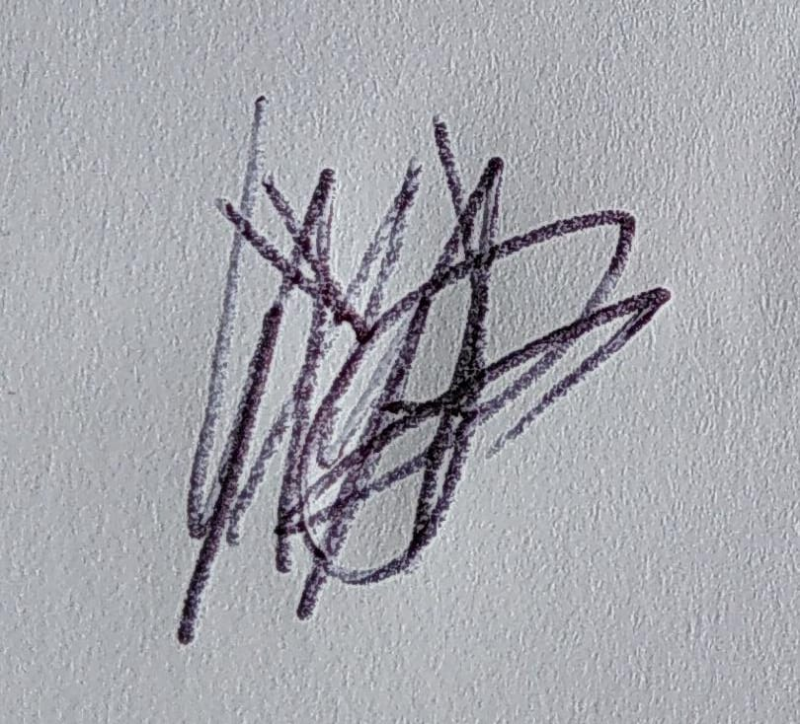

Name and position in group …HEATHER MCKNIGHT TREASURER

Signed 