Arts for life Constitution
Aims

- Promoting wellbeing to disadvantaged and vulnerable people, supporting them to develop their creative practice and self expression through a variety of Art forms, including but not limited to: visual arts, performance, puppetry, music, animation, eco art.
- To develop the capacity and skills of the members of these socially or economically disadvantaged communities in such a way that they are better able to identify, and help meet, their needs and to participate more fully in society
- To facilitate the use of eco art regularly, educating on environmental issues, making arts more inclusive to people on a low budget with the use of upcycled materials.
- To support Integration and connection with the local community, through encouraging collaboration within this group and other groups, enabling the breakdown of societal barriers and further build a sense of community inclusion
- To enhance self confidence and communication skills through mentoring and peer support in the arts

Membership

Membership is open to anyone, any age who:
- Comes from a minority group/and/or vulnerable
- Wishes to develop through creative expression
- Supports the aims of the group
Membership will begin when the membership form has been completed and returned.
A list of all members will be kept by the membership secretary.

Ceasing to be a member

Members may resign at any time in writing to the secretary.
Any offensive behaviour, including racist, sexist or inflammatory remarks, will not be permitted.
Anyone behaving in an offensive way or breaking the equal opportunities policy may be asked
not to attend further meetings or to resign from the group if an apology is not given or the
behaviour is repeated. The individual concerned shall have the right to be heard by the
management committee, accompanied by a friend, before a final decision is made.

Equal opportunities

Arts for life will not discriminate on the grounds of background, disability, race, sexual orientation, religious or political belief, gender reassignment, marital status, pregnancy or maternity, age.

Officers and committee

The business of the group will be carried out by a Committee elected at the Annual General
Meeting. The Committee will meet when necessary and not less than four times a year.
The Committee will consist of 3 members. Up to 2 additional members may be co-opted onto the committee at the discretion of
the committee.
The officers’ roles are as follows:
• Chair, who shall chair both general and committee meetings
• Secretary, who shall be responsible for the taking of minutes and the distribution of all papers.
- Treasurer, responsible for maintaining accounts
In the event of an officer standing down during the year a replacement will be elected by the next General Meeting of members.
Any committee member not attending a meeting without apology for three months will be
contacted by the committee and asked if they wish to resign.
The Committee meetings will be open to any member of Arts for life
wishing to attend, who may speak but not vote.
The committee may invite other people to co-opt for use of particular skills or knowledge.

Meetings
Annual General Meetings

The AGM will be run by the committee, all members welcome. Members will be emailed.or texted the date, time and venue at least 1 month before.
The AGM will happen at least every 15months
Members can submit items for discussion up to 1 month before.
Committee elections and constitution amendments can take place if desired.
The quorum for the AGM will be one third of the total number of members.

Special general meetings
The Secretary will call a Special General Meeting at the request of the majority of the committee
or at least eight other members giving a written request to the Chair or Secretary stating the
reason for their request.
The meeting will take place within twenty-one days of the request.
All members will be given two weeks notice of such a meeting, giving the venue, date, time and agenda, and notice may be by telephone or email.
The quorum for the Special General Meeting will be one third of the total number of members.

General meetings
General Meetings are open to all members and will be held at least once every 3 months or more often if necessary.
All members will be given two weeks’ notice of such a meeting, giving the venue, date, time and agenda, and notice may be by telephone or email.
The quorum for a General Meeting shall be one third of the total number of members.

Committee meetings
Committee meetings may be called by the Chair or Secretary. Committee members must receive notice of meetings at least 7 days before the meeting.
Committee meetings will happen once a year, this can be via video or at a venue.
The quorum for Committee meetings is three Committee members.

Rules of procedure for meeting
All questions that arise at any meeting will be discussed openly and the meeting will seek to find a general agreement that everyone present can agree to.
If a consensus cannot be reached a vote will be taken and a decision will be made by a simple majority of members present. If the number of votes cast on each side is equal, the chair of the meeting shall have an additional casting vote.

Finances
An account will be maintained on behalf of the Association at a bank agreed by the committee. Two cheque signatories will be nominated by the Committee (To be the Chair and Secretary). The signatories must not be related nor members of the same household.
All payments will be signed by the signatories.

For payments (such as BACS payments, cash withdrawals, debit card payments or cash payments), a requisition note will be signed by two signatories, and held by the Chair.
Records of income and expenditure will be maintained by the chair and a financial statement given at each meeting.

All money raised by or on behalf of Arts for life is only to be used to further the aims of the group, as specified in item 2 of this constitution.

Amendments to the constitution
Amendments to the constitution may only be made at the Annual General Meeting or a Special General Meeting.
Any proposal to amend the constitution must be given to the Secretary in writing. The proposal must then be circulated with the notice of meeting.
Any proposal to amend the constitution will require a two thirds majority of those present and
entitled to vote.

Dissolution
If a meeting, by simple majority, decides that it is necessary to close down the group it may call a Special General Meeting to do so. The sole business of this meeting will be to dissolve the group.
If it is agreed to dissolve the group, all remaining money and other assets, once outstanding debts have been paid, will be donated to a local charitable organisation. The organisation will be agreed at the meeting which agrees the dissolution.

This constitution was agreed at the Inaugural General Meeting of Arts for life

Date 23/10/2023

Name and position in group …EMMA OTTLEY CHAIR

Signed 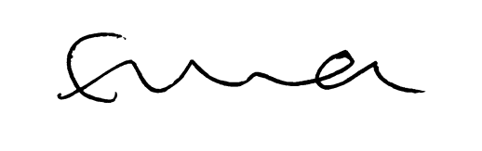

Name and position in group …LAYLA JADE REDWAY MAGUIRE SECRETARY

Signed

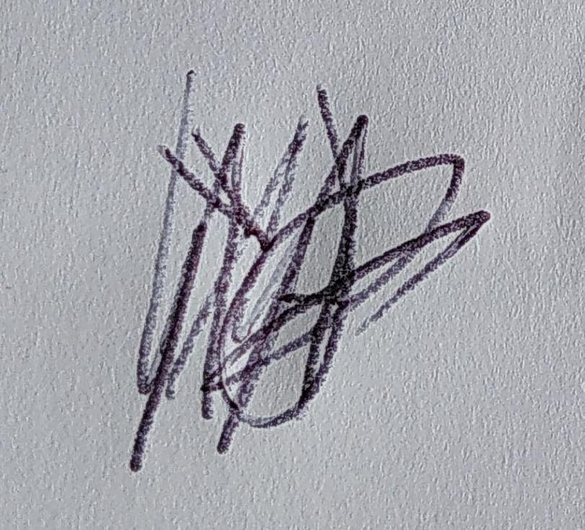

Name and position in group …HEATHER MCKNIGHT TREASURER

Signed 